Upgrade Notice for Lower Versions_English
Note: For lower version upgrades, you must update the configuration file and upgrade the system according to the following steps

- Updating the configuration file
- Open folder path “D:\RitonConfigurationFiles\DeviceParasFile”
- Open “ParametersConfiguration.ini”
- Add two lines of parameters to the end of the configuration file：
CocrType=CoCr-30um
LayerType=Support,NonSolidSupport,Contour,Solid
IsNewLaser=True
PhotographVisible=False
IsPowderDetection=False
DetectCircle=179,129,158,56,2009,966,728.949152542373,0
DetectRectangle=160,132,281,265
- Refer to the chart below
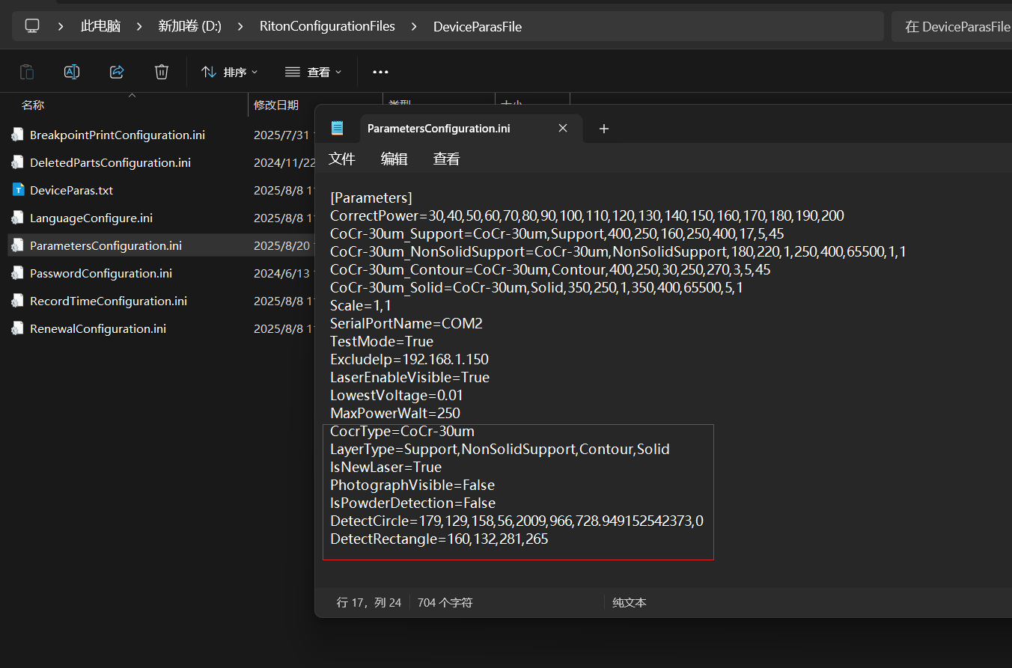

5、Add a configuration file, as shown in the following figure
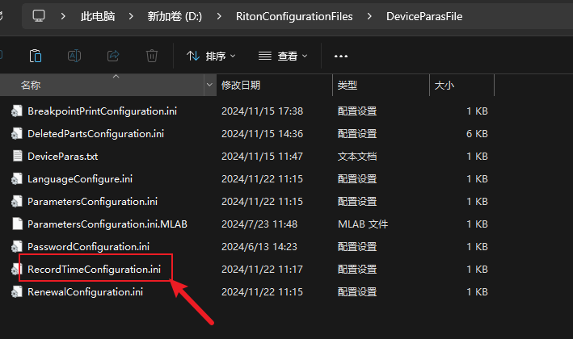
- Uninstalling old programs
- Open the Control Panel and double-click to open Programs and Features
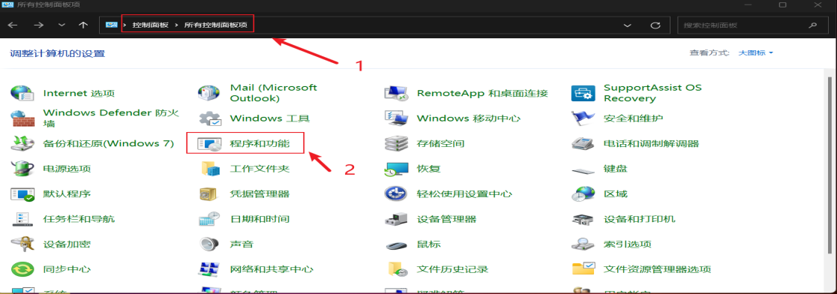
- Uninstallation RitonController
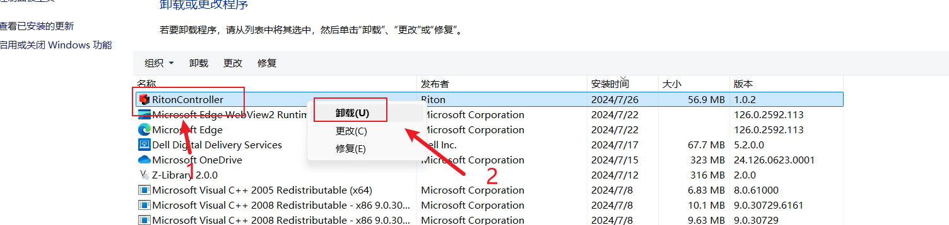

- Installation procedures
- Open the unzipped file for installation
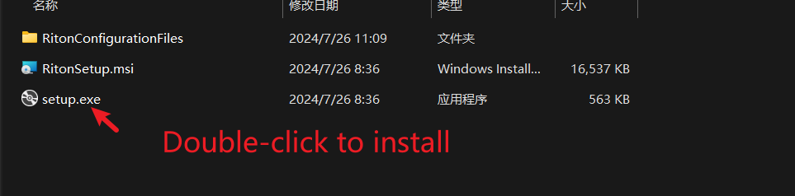
- click on the next step, the installation path appears, please modify the path from the C disk into the D disk, as follows
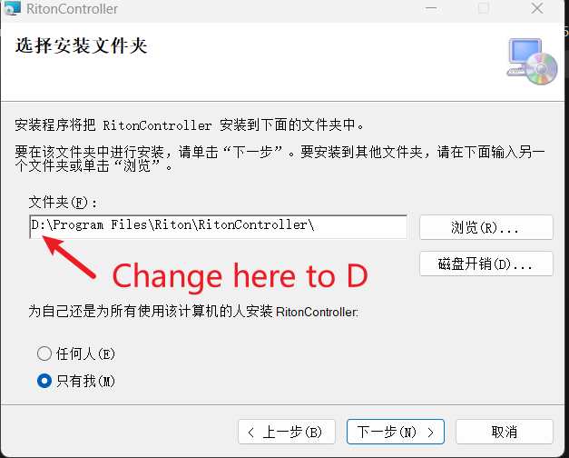
- Behind the next step to continue to install can be completed

